Dependency Detective
Software Supply-Chain Risk Analyzer

Project Detail | Information
Project Name | Dependency Detective – Software Supply-Chain Risk Analyzer
Course / Domain | Software Supply-Chain Security / Dependency Risk Analysis
Input | Supported dependency files, lockfiles and pasted dependency textPython requirements.txt dependency list
Technology Stack | Supported dependency files, lockfiles, manifests and pasted dependency text
Advisory Source | OSV.dev API and bundled sample advisory records
Documentation Date | 24 October 2026

Parse → Validate → Look Up Advisories → Match Versions → Recommend → Report

1. PROJECT OVERVIEW
Dependency Detective is a software supply-chain risk analyzer. Users can upload supported dependency manifests and lockfiles or paste dependency text, inspect package-level vulnerability findings, review remediation guidance, explore dependency relationships, and export ecosystem-specific reports. The interface is designed to trace dependency risk while retaining clear status labels for incomplete checks.

Problem Statement
Python applications often rely on third-party libraries. A package version may have a publicly reported vulnerability, but developers need a practical way to identify affected versions, understand the available evidence, and decide whether an upgrade should be investigated. Manual checking can be time-consuming and inconsistent.

Project Objectives
- Read and parse supported dependency files, lockfiles and pasted dependency text .
- Recognize supported ecosystem formats, versions and version constraints, duplicate entries, malformed lines, comments and skipped or unsupported entries.
- Check package versions against online vulnerability advisory data or bundled/cached offline advisory data where supported.
- Match supported package versions against advisory affected ranges, list confirmed matches and expose package relationships where available.
- Recommend an upgrade only when advisory data supports a suitable fixed version, and present a fix plan for review.
- Display findings, fix plans, dependency graphs and all-package views; export reports and ecosystem-specific ZIP bundles; and retain scan history for comparison.
Important interpretation: “No matching record” means no matching advisory was found in the selected source. It does not prove that a package is safe.

Scope
The interface accepts supported dependency files by upload or pasted text and advertises coverage . The screenshots show examples including requirements.txt, package-lock.json, Cargo.lock, conanfile.txt and .csproj files. Exact parsing depth and dependency-graph completeness depend on the supported format; entries that cannot be resolved should be reported as incomplete rather than treated as safe.

End-to-End Workflow
Stage | Purpose
1. Upload or paste | Provide requirements.txt content to the application.
2. Validate | Check that the input is acceptable for scanning.
3. Parse | Extract package names, version specifiers, markers and line-level notes.
4. Advisory lookup | Use OSV.dev online or local sample/cache data.
5. Version matching | Compare exact versions with advisory affected ranges.
6. Remediation | Suggest a fixed version only when the evidence supports it.
7. Report and history | Show findings, export reports and compare saved scans.

2. TEAM MEMBERS, RESPONSIBILITIES AND COLLABORATION
The same team members and names used in the Nike Sales documentation are retained. Responsibilities are adapted to the Dependency Detective software project so that the work is organized across inspection, validation, core logic, testing, interface and documentation.
Team Member | Primary Responsibility | Team Contribution
G. Sai Kumar | Documentation & Coordination | Coordinates the written record, project workflow explanation, progress notes and final submission material.
T. Indravathi | Input Inspection & Parsing | Reviews requirements-file structure, package entries, version specifiers, comments, duplicates and malformed lines.
S. Jyothirmayi | Core Logic & Advisory Matching | Focuses on package/version matching and checks how advisory records are compared with affected version ranges.
P. Ganesh | Validation & Testing | Reviews validation cases, incomplete-check states, scan results and consistency between findings and reports.
M. Anjali | User Interface & Reporting | Focuses on presenting scan summaries, tables, visual summaries, exports and scan history clearly.

How the Work Connects
- Input inspection identifies the formats and edge cases that the parser must handle.
- Parsing produces structured package entries for the scanner.
- Advisory matching checks exact versions against source-provided vulnerability records.
- Remediation logic uses fixed-version evidence to determine whether an upgrade can be suggested.
- Validation and tests help check behavior for normal, malformed and incomplete inputs.
- The UI and reporting utilities present the output, while history enables before-and-after comparison.
- Documentation explains the complete workflow and the limitations that users must understand.

Teamwork Principle
The project is a connected workflow rather than a set of isolated tasks. Parser output feeds the scanner; scanner results feed remediation and reports; and testing checks that the user-facing results represent the underlying analysis.

Project Structure
Path / File | Role
app.py | Main Streamlit application and scan results interface.
pages/1_History.py | Displays saved scans and compares two reports.
backend/core/parser.py | Parses requirements entries and classifies their version state.
backend/core/matcher.py | Matches package versions against advisory affected ranges.
backend/core/scanner.py | Coordinates parsing, lookup, matching, remediation and summary creation.
backend/core/remediation.py | Creates evidence-based upgrade recommendations.
backend/services/osv_service.py | Calls the OSV.dev API and caches advisory details.
backend/utils/db.py | Stores scan history and advisory cache in SQLite.
backend/utils/report.py | Exports scan reports to JSON, CSV and Markdown.
tests/ | Automated tests for parser, scanner and related behavior.

3. INPUT DATA AND REQUIREMENTS INSPECTION

Input Files and Ecosystem Detection
The application accepts dependency files by drag-and-drop/browse or dependency text pasted into the input area. The interface advertises support , with visible examples such as requirements.txt, package-lock.json, Cargo.lock, conanfile.txt and .csproj files. The parser identifies the ecosystem and interprets entries according to the supported file format.

What the Parser Checks
- Blank lines and comments are ignored for package scanning.
- Line continuations using a backslash are joined before parsing.
- Hash options are removed from a requirement entry before interpretation.
- Exact pinned versions can be checked directly when the selected ecosystem format supplies a resolvable version.
- Version ranges or entries without a resolvable version may be marked unresolved because the exact version is unknown.
- Malformed requirement lines are identified rather than treated as valid package entries.
- Unsupported options, URLs and local paths are marked skipped when the selected parser cannot analyze them.
- Repeated package names are noted as duplicates.

Example Input (Python requirements format)
flask==2.0.0\nrequests==2.25.0\nPyYAML>=6.0\npandas\nthis is not a valid requirement\n-r other-requirements.txt

Example Interpretation
Entry | Possible parser state | Meaning
flask==2.0.0 | Exact version | A specific version is available for advisory matching.
PyYAML>=6.0 | Unresolved | A range is specified, so one exact version is not known.
pandas | Unresolved | No version is pinned.
Invalid text | Malformed | The line could not be parsed as a requirement.
-r other-requirements.txt | Skipped | Include directives are outside the current scanner’s supported checks.

Why Inspection Matters
If input lines are interpreted incorrectly, a scanner may miss dependencies or imply that an entry was checked when it was not. Clear per-line statuses help users distinguish a confirmed advisory match from an incomplete check.
Implementation boundary: The project scans direct entries from the supplied text. It does not install packages or execute the requirements file.

4. SYSTEM ARCHITECTURE AND SCAN PROCESS
The application separates the Streamlit interface from backend parsing, advisory lookup, version matching, remediation, database and report utilities.
Component | Responsibility | Output
Streamlit UI | Collects input, selects scan mode and presents results. | User input and result views
Validators | Checks uploaded/pasted input against application constraints. | Accepted input or validation feedback
Parser | Converts lines into structured entries with package, specifier, version and status. | Parsed dependency records
OSV service | Queries OSV.dev and retrieves advisory records; caches fetched records. | Advisory data or lookup warning
Matcher | Checks whether a pinned package version is affected by an advisory. | Matching vulnerability records
Remediation | Evaluates fixed-version evidence across findings. | Suggested version or explanatory note
Report utility | Formats package results and findings. | JSON, CSV or Markdown
SQLite utility | Stores scan reports and advisory cache. | History and cached records

Scan Logic
- The scanner parses the requirements text into line-level entries.
- It collects unique package/version pairs for entries with exact versions.
- In online mode, the OSV.dev API is queried; in offline mode, bundled sample advisories and cached OSV records are combined.
- Each exact version is checked against matching advisory data.
- Findings include advisory identifiers, source-provided severity where available, summaries, fixed versions and references.
- The scanner builds a package status summary and warning list.
- The report is shown in the UI and can be exported or saved to history.

Online and Offline Modes
Mode | Data source | Practical consideration
Online | Live OSV.dev API; fetched advisory details may be cached. | Requires network access. A lookup failure is reported rather than treated as a clean result.
Offline | Bundled sample advisory snapshot plus previously cached OSV records. | Works without a live lookup but the bundled subset may be incomplete or out of date.

Result States
State | Meaning
Confirmed match / vulnerable | A matching advisory record indicates the pinned package version is affected.
No matching record | No advisory match was found in the selected data source. This is not a guarantee of safety.
Unresolved version | The entry does not provide one exact version that can be checked.
Lookup unavailable | The online advisory lookup failed, so the check could not be completed.
Malformed line | The requirement entry could not be parsed.
Skipped option | The line is an option, URL or path that the scanner does not analyze.

5. VERSION MATCHING AND REMEDIATION

Advisory Matching
The matcher uses advisory records and ecosystem/package identifiers to compare supported package versions with affected versions and ranges. Where the source provides range events such as introduced, fixed and last_affected, these are used to determine whether a version falls within an affected interval. Matching behavior depends on the ecosystem metadata available in the advisory.

Evidence Included in Findings
- Package name and pinned version.
- Advisory identifier and any available aliases.
- Short advisory summary.
- Severity information supplied by the source, when available.
- Fixed versions listed in the advisory data, when available.
- Modification timestamp and references, including the OSV record URL.

Upgrade Recommendation Rules
The remediation component does not guess a version simply because a package is vulnerable. It gathers fixed versions supported by the matching advisories, checks that the candidate is not still marked affected by the findings, and returns a recommendation only when the evidence is sufficient.
Current pinned version + advisory fixed-version evidence\n ↓\nCheck candidate against all findings\n ↓\nSuggest upgrade only when evidence supports it

Compatibility caveat: An advisory-supported fixed version is not guaranteed to be compatible with the application. Re-scan after upgrading and run the project’s tests.

Severity and Interpretation
Severity is taken from the advisory source when available. If the source does not provide a severity label, the scanner may display available CVSS-related information or “Not provided.” The project should not be interpreted as independently calculating a complete risk score.

Responsible Use
- Treat incomplete checks as work that still needs review.
- Do not interpret a clean-looking result as proof that a package has no vulnerabilities.
- Review advisory references and release notes before upgrading.
- Keep dependency files current and re-run scans after changes.

6. USER INTERFACE, VISUAL SUMMARIES AND ECOSYSTEM EXPORTS
The interface starts with a dependency-file upload area and a text-paste option. It then organizes scan results into Findings, Fix plan, Dependency graph, All packages, Export and History views. The export screen groups packages by ecosystem and provides a separate ZIP download for each ecosystem represented in the scan.
Figure 1. Dependency-file intake supports file upload or pasted dependency text, with examples of supported manifest and lockfile formats.
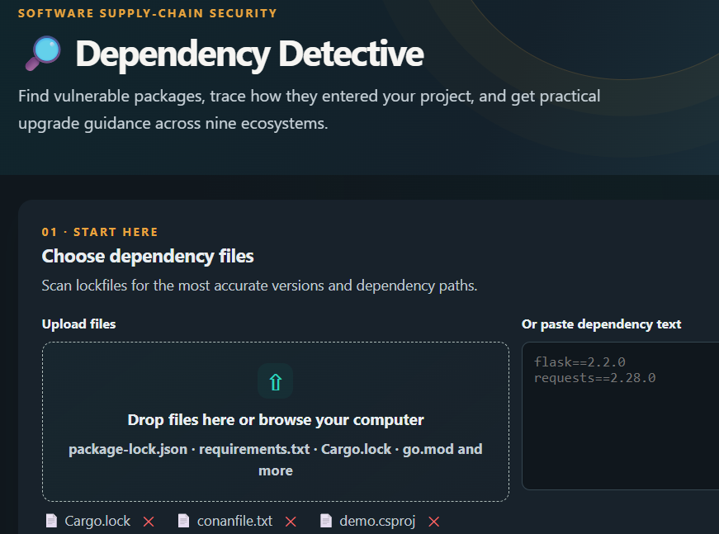
Figure 2. Export view groups scan packages by ecosystem and offers a separate ZIP download for each ecosystem.
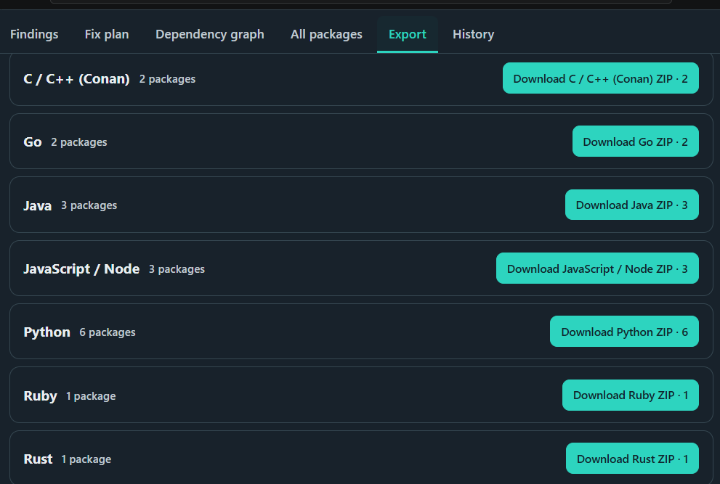
Ecosystem export behavior shown in the supplied screenshot: C/C++ (Conan), Go, Java, JavaScript/Node, Python, Ruby and Rust are visible, each with its package count and ZIP download. The page heading states that the analyzer covers nine ecosystems; the other two ecosystem labels are not visible in this screenshot.

Main Results and Navigation
- A summary of scanned dependency entries and confirmed findings.
- Advisory details for affected package versions, including available identifiers, severity and references.
- A fix plan with upgrade suggestions only where the available advisory evidence supports them.
- A separate area for unresolved, malformed, skipped or unavailable checks.
- Package-level filtering to help users focus on a selected result status.

Visual Summaries
The app uses Plotly for interactive summaries. A status pie chart shows package counts by check result. When severity information is available, a bar chart summarizes advisories by the source-provided severity values. These charts describe the current scan output; they do not represent an independent security certification.

Export Formats
Format |  | Purpose |  | Typical contents
JSON |  | Machine-readable record for later processing. |  | Scan time, mode, summary, package records, findings and warnings.
CSV |  | Spreadsheet-friendly package list. |  | Line, package, version, status, advisory count and recommendation fields.
Markdown |  | Readable report for sharing or documentation. |  | Summary, confirmed findings, suggested upgrades, incomplete checks and disclaimer.
Format | Purpose |  | Typical contents
JSON | Machine-readable record for later processing. |  | Scan time, mode, summary, package records, findings and warnings.
CSV | Spreadsheet-friendly package list. |  | Line, package, version, status, advisory count and recommendation fields.
Markdown | Readable report for sharing or documentation. |  | Summary, confirmed findings, suggested upgrades, incomplete checks and disclaimer.

The export workflow should preserve the ecosystem label and package count shown on screen. A downloaded ZIP is a convenience for reviewing the selected group; it should not be interpreted as a statement that every package in the group has been fully resolved or found free of vulnerabilities. Users should retain the scan date, lookup mode and any warnings alongside the exported file.

Scan History and Comparison
The History page lists saved scans and allows an earlier report to be compared with a later report. The comparison groups findings into newly introduced, resolved and still-present items using package, version and advisory ID.
Earlier scan + Later scan\n ↓\nCompare (package, version, advisory ID) keys\n ↓\nNewly introduced | Resolved | Still present

Storage note: The project uses SQLite for local scan history and advisory caching. The README notes that local SQLite storage on Streamlit Community Cloud is temporary and can be lost when the app restarts.

7. INSTALLATION, EXECUTION AND TESTING

Prerequisites
- Python 3.11 or 3.12 (the README names Python 3.12 in its technology stack).
- Git for cloning the project, if using a repository.
- Internet access for online advisory lookup; offline mode uses local sample/cache data.

Install Dependencies
python -m venv .venv\n# Activate the virtual environment for your operating system\npip install -r requirements.txt\n

Run the Application
streamlit run app.py

After the application starts, open the local URL printed in the terminal. Upload one or more supported dependency files or paste dependency text, select the available advisory source mode, and start a scan.

Run Automated Tests
python -m pytest -q

The project README states that the test suite contains 26 tests covering parsing, version boundaries, remediation, online lookup failure, exports and validation. This count is reported from the README; it is not a claim that the tests were executed as part of preparing this document.

Suggested Test Scenarios
Scenario | Expected behavior to verify
Exact pinned version | A version/advisory lookup is attempted.
Version range or no pin | The entry is marked unresolved.
Malformed requirement | The line is identified as malformed.
URL, local path or option | The entry is marked skipped.
Online API failure | The lookup is reported unavailable rather than silently treated as no match.
Advisory includes fixed version | Recommendation logic checks whether the suggested target addresses all matched findings.
Export report | JSON, CSV and Markdown downloads reflect the scan result.
Compare two scans | New, resolved and persisting findings are separated.

8. LIMITATIONS, FUTURE ENHANCEMENTS AND CONCLUSION

Known Limitations
- The interface advertises support for nine ecosystems and accepts multiple dependency-file formats; exact format support should be verified against the current implementation.
- Coverage and dependency-relationship depth can vary by ecosystem and input format; do not assume every uploaded format provides a complete transitive dependency tree.
- Unpinned versions and version ranges remain unresolved rather than being resolved to an installed version.
- The bundled advisory data is a small demonstration subset; online scans are needed for fresher coverage.
- Pagination for very large OSV result sets is not handled.
- SQLite history may be temporary on Streamlit Community Cloud.
- Upgrade recommendations may not be compatible with every application.

Future Enhancements
- Continue broadening lockfile coverage and validate dependency-graph completeness across all supported ecosystems.
- Add compatibility checks and automated test execution after a suggested upgrade.
- Provide clearer explanations of advisory evidence and affected version ranges.
- Improve persistence and retention controls for scan history.
- Add more sample scenarios and broaden test coverage for edge cases.

Final Review Checklist
- ☐ Project purpose and scope documented.
- ☐ Team members and responsibilities retained from the reference team document.
- ☐ Input parsing and result statuses explained.
- ☐ Online and offline advisory lookup described.
- ☐ Version matching and evidence-based remediation explained.
- ☐ UI, visual summaries, exports and history documented.
- ☐ Installation, execution and testing instructions included.
- ☐ Limitations and responsible-use cautions stated.

Conclusion
Dependency Detective provides a structured workflow for reviewing dependencies across multiple software ecosystems against known vulnerability advisory data. It parses supported files or pasted text, distinguishes confirmed matches from incomplete checks, presents source evidence, and suggests upgrades only when advisory data supports a candidate. Dependency graph and package views help users inspect the scan, while ecosystem-specific ZIP exports and scan history support reporting and comparison.
The tool is an aid for dependency review, not a guarantee of security. Results depend on the advisory source and the versions that can be resolved from the input. Developers should review source records, validate suggested upgrades, run their own tests and re-scan after changes.

9. SUPPORTED INPUT FORMATS AND ECOSYSTEM WORKFLOW

Purpose
The interface is designed to accept dependency information in several ecosystem-specific formats. The supplied screenshots show an upload area, a text-paste area, and selected-file chips. They also show export groups for C/C++ (Conan), Go, Java, JavaScript / Node, Python, Ruby and Rust. The interface describes broader ecosystem coverage, but the screenshots do not identify every ecosystem by name. This report therefore records only the names that are visible.

Input handling
A user can browse for dependency files or drag files into the upload area. Alternatively, dependency text can be pasted directly into the text box. The application should retain the original file name and detected ecosystem where available, because those details help users interpret results and choose the appropriate export. Before analysis begins, the input should be checked for supported file types, reasonable size, empty content and unreadable text.

Ecosystem-specific parsing
Dependency formats are not interchangeable. A requirements file, a JavaScript lockfile, a Go module file and a Rust lockfile express package information differently. The parser should select the appropriate interpretation for the detected format rather than treating every line as a Python requirement. Where a file format cannot be identified confidently, the application should ask the user to select a format or report that the file was not analyzed.

Version and path information
Where the input contains exact versions and dependency relationships, those values can support version matching and dependency-path explanations. Where a format does not provide enough information, the result should be marked unresolved instead of implying that the package was fully checked. The same principle applies to malformed files and unsupported syntax.

10. USER INTERFACE WALKTHROUGH

Start Here
The first screen introduces Dependency Detective and explains its purpose: finding vulnerable packages, tracing how dependencies entered a project, and presenting practical upgrade guidance. The first workflow step is to provide dependency files. The upload panel accepts files from the computer, while the adjacent text area allows a dependency list to be pasted. Selected files appear below the upload area and can be removed individually.

Findings
The Findings section is the main place to review the scan outcome. A useful review begins with the overall summary and then moves to individual packages. Users should examine the package name, installed or pinned version, advisory identifier, severity when supplied, affected-version evidence and available references. Any result that is unresolved or unavailable should be reviewed separately from confirmed vulnerability matches.

Fix plan
The Fix plan section organizes possible remediation actions. Recommendations should be treated as candidates supported by advisory evidence, not as automatic permission to upgrade without testing. A developer should review the target version, check release notes and compatibility requirements, update the dependency file, and run the project's tests.

Dependency graph and All packages
The Dependency graph is intended to help users understand dependency relationships and trace a package's place in the project. The All packages view provides a broader inventory so that users can review packages even when no matching advisory is shown. These views complement each other: one emphasizes relationships and the other emphasizes coverage.

Export and History
The Export section groups downloadable ZIP outputs by ecosystem and shows package counts for each group. The History section allows saved scans to be revisited and compared. Users should confirm that an exported package group is the intended one and preserve the scan date and mode when using reports as project evidence.

11. EXPORTS, REPORT CONTENT AND TRACEABILITY

Purpose of export
Exports make scan results easier to share with teammates, retain for project records, and compare during later reviews. A report should preserve enough context to explain what was checked and what remains uncertain. An export is most useful when it includes the scan time, selected lookup mode, input file or ecosystem, package inventory, finding status and advisory references.

Ecosystem ZIP downloads
The supplied Export screenshot shows separate download controls for C/C++ (Conan), Go, Java, JavaScript / Node, Python, Ruby and Rust. The visible package counts differ by ecosystem. Those counts should be interpreted as the number of packages represented in each export group, not as the number of vulnerabilities. A package count alone does not indicate whether the dependencies are secure.

Report consistency
The information in an export should match the results displayed in the interface. Package names, versions, advisory identifiers and remediation targets should not change between the Findings view and the downloaded report. If a scan has incomplete lookups, malformed entries or unsupported inputs, the report should include those warnings so a recipient does not mistake an incomplete result for a clean scan.

Traceability
Each finding should provide a reference to the advisory source when one exists. Source links allow developers to confirm the affected range and fixed-version details. When a source does not provide severity or a fixed version, the report should state that the value is not provided rather than inventing one. Clear evidence and explicit uncertainty make the report more reliable.

Retention
Reports can be retained with a release, pull request or maintenance ticket. When comparing reports, users should record which dependency file was scanned and whether online or offline data was selected. This makes it easier to explain why two scans differ.

12. SECURITY FINDING REVIEW PROCEDURE

Initial triage
Begin by separating confirmed matches from unresolved versions, malformed lines, skipped entries and unavailable lookups. Prioritize confirmed matches for review, while keeping incomplete checks visible as follow-up work. Do not combine all non-vulnerable-looking states into one category, because each state represents a different level of evidence.

Validate the advisory
Open the advisory reference and verify that the package identity and ecosystem match the dependency under review. Read the affected-version range and any fixed-version information. Check whether the advisory includes aliases, a modification date or additional references. If the source data is ambiguous, record the uncertainty and seek maintainer guidance before making a production change.

Assess project exposure
A version match indicates that the advisory describes the package version as affected; it does not by itself establish the practical impact in every application. The project team should consider how the package is used, whether the affected functionality is reachable, and whether a mitigation is documented. This contextual assessment supplements rather than replaces the scanner result.

Select a remediation
Prefer a target version explicitly supported by the advisory data and verify that it addresses all findings associated with the package. Review release notes, compatibility constraints and any required configuration changes. If there is no evidence-supported fixed version, document that limitation and consult the package maintainer or advisory references.

Verify after change
After updating a dependency, re-run the scan against the revised file and execute the project's normal test suite. Confirm that the expected finding is resolved and check whether the change introduces new advisories or compatibility failures. Preserve the before-and-after reports when the change is important for audit or team review.

13. TEST PLAN AND QUALITY ASSURANCE

Parser tests
Parser tests should cover valid exact pins, version ranges, unpinned packages, comments, blank lines, line continuations, duplicate package names, malformed entries, URLs, local paths and include options. Expected outcomes should be explicit for every test case. A parser should not silently convert invalid text into a valid dependency.

Matching tests
Version matching should be tested at the boundaries of advisory ranges. Cases should include a version before the affected range, a version inside the affected range, a version at a fixed boundary and a version after the fix. Tests should also cover explicit affected-version lists and records with incomplete range information.

Lookup tests
Online lookup tests should verify successful responses, empty advisory responses, network failures, timeouts and invalid or unexpected data. A failed online request must be reported as unavailable rather than converted into a no-match result. Offline tests should confirm that the bundled sample data and cached records are used according to the selected mode.

Remediation tests
Recommendation tests should cover advisories with a fixed version, advisories without a fixed version, multiple findings for one package and candidate versions that remain affected by another finding. The system should recommend an upgrade only when the available evidence supports it.

Interface and export tests
Interface tests should verify file upload, pasted text, selected-file removal, ecosystem grouping, result filtering, download controls and history navigation. Export tests should compare package records and finding details against the on-screen result. The documented README reports 26 tests; this statement reflects the project documentation and does not assert that the suite was executed while preparing this report.

Acceptance criteria
The scan should complete for supported inputs, preserve warnings for incomplete checks, distinguish finding states, avoid unsupported remediation claims and produce exports consistent with the displayed results. Test outcomes should be recorded with the software version and test command.

14. ERROR HANDLING AND USER FEEDBACK

Input errors
When a file is empty, too large, unreadable or unsupported, the interface should explain the problem and provide a clear next step. For example, the user may choose a supported file, paste valid dependency text or remove an invalid upload. Error messages should identify the relevant file or entry where possible.

Network and advisory errors
Online advisory services can be unavailable because of connectivity, rate limits or service-side problems. The application should distinguish these failures from a successful lookup that returns no matching advisory. A concise warning should identify that the check could not be completed and, where appropriate, suggest retrying or selecting offline mode.

Partial scans
A single invalid entry should not obscure the status of all other entries. Where practical, the application should continue scanning valid dependencies and report the skipped or malformed entries separately. The summary should make partial coverage clear, and exports should retain the same warnings.

Safe messages
Error messages should help users recover without exposing secrets, environment variables or unnecessary internal details. Dependency files can contain private package names or repository URLs, so reports and logs should avoid including sensitive credentials. Users should inspect files before sharing them outside their team.

Repeatability
A scan should retain its input context, mode and time so that users can understand the result later. If advisory data is cached, the interface should not imply that cached information is necessarily current. Clear mode labels and warnings improve the interpretation of repeat scans.
Input and parser assumptions
The quality of a scan depends on whether the supplied file is complete and whether its format is recognized correctly. Partial manifests, generated files that do not reflect the deployed environment, and unsupported syntax can leave gaps in the inventory. Teams should scan the dependency files used by the actual build or deployment process and check the scan summary for skipped or unresolved entries.

Operational assumptions
Online analysis depends on network access and the availability of the advisory service. Offline analysis depends on the records bundled with the application and previously cached data. The age and coverage of those records should be considered when interpreting results. If an important check is unavailable, rerunning later or reviewing the advisory source directly may be necessary.

Data handling and privacy
Dependency files may reveal internal package names, private repository locations or project structure. Before uploading or sharing files and reports, users should inspect them for confidential information. The tool should avoid logging credentials or other secrets and should clearly communicate when data is sent to an external advisory service.

15. LIMITATIONS, ASSUMPTIONS AND RESPONSIBLE USE

Coverage limitations
The analyzer depends on the formats it supports, the package information present in the input and the coverage of the selected advisory source. A package omitted from the input cannot be assessed by that scan. An unsupported syntax or ecosystem may also prevent a complete analysis.

Advisory-data limitations
Public advisory databases can differ in timing, detail and completeness. Bundled sample data is useful for demonstrations and offline checks, but it may not reflect the newest disclosures. Cached records can also become stale. Users should select online lookup when current remote data is required and available.

Version-resolution limitations
A dependency constraint is not always the same as the exact version installed in an environment. If the input specifies only a range or omits a version, the analyzer may not know which version is actually present. The result should remain unresolved unless the project supplies enough information for a reliable comparison.

Recommendation limitations
An advisory-supported fixed version is not guaranteed to be compatible with every application. Upgrading can require code changes or introduce behavior changes. The analyzer does not replace application testing, code review or a maintainer's release guidance.

Responsible use
Treat the tool as a decision-support aid. Review confirmed findings, resolve incomplete checks, validate proposed versions and run tests after changes. Do not describe a scan as a security certification, and do not interpret an absence of matching records as proof that the project is free of vulnerabilities.

16. FUTURE DEVELOPMENT ROADMAP

Broader dependency resolution
A future version could improve lockfile handling and dependency-tree analysis where supported by the relevant ecosystem. This would help users understand not only direct dependencies but also packages introduced indirectly. Any new parser should be accompanied by representative fixtures and tests for format-specific edge cases.

Richer dependency graph
The graph view could provide clearer parent-child paths, distinguish direct from transitive relationships when that information is available, and let users navigate from a package to its associated findings. Graph labels should remain readable for large projects, and the interface should explain when a relationship is unknown.

Improved remediation support
Future work could compare candidate versions with project constraints, display release-note links and explain why a target version was selected. Automated changes should remain optional and should require review before files are modified. Compatibility checks should be reported separately from vulnerability evidence.

Persistent history
The history feature could offer configurable retention, exportable comparison summaries and more durable storage for deployments where local SQLite persistence is not guaranteed. Access control and data-retention expectations should be documented if the application is used by multiple people.

Operational quality
Additional improvements may include clearer progress feedback, retry handling, accessibility checks, larger test fixtures and performance testing on representative dependency files. Each enhancement should be prioritized against actual user needs and validated with tests before release.

17. DEPLOYMENT, MAINTENANCE AND RELEASE CHECKLIST

Environment setup
Use a supported Python environment and install the project's pinned or documented dependencies in an isolated virtual environment. Keep installation instructions consistent with the repository's requirements file. Avoid mixing project dependencies with unrelated global Python packages.

Configuration
Document which settings control online and offline lookup, cache behavior and database location. Secrets or credentials should not be placed in source code or dependency files. If external services require configuration, provide safe defaults and explain the minimum required settings.

Pre-release checks
Before a release, run the automated test suite, inspect dependency updates, confirm the application starts successfully and test a representative input for each supported format. Verify that warnings, findings, remediation suggestions and exports remain consistent.

Deployment considerations
A hosted deployment should be tested with the same input constraints and lookup behavior expected by users. The project documentation notes that local SQLite storage on Streamlit Community Cloud may be temporary. A deployment that requires durable history should use a storage approach appropriate to its persistence requirements.

Maintenance
Review advisory-source behavior, update dependencies responsibly and re-run tests after code changes. Keep the README, interface labels and project report aligned when supported formats or features change. Release notes should identify significant behavior changes and known limitations.

Release checklist
Confirm that the input flow works, supported formats are identified accurately, online lookup failures remain visible, the offline mode is clearly labelled, recommendations include supporting evidence, export downloads work and the history comparison is understandable. Record the version and date of the release.

18. PROJECT SUMMARY AND CONCLUSION

Summary
Dependency Detective organizes dependency inspection into a practical workflow: provide dependency information, validate and parse it, look up vulnerability advisories, compare versions, review findings, consider evidence-supported fixes and export the results. The interface shown in the supplied screenshots includes file upload and pasted-text input, findings and fix-plan navigation, a dependency graph, an all-packages view, ecosystem-specific export groups and scan history.

Value to users
The project helps developers and student teams make dependency review more systematic. It gathers package information and advisory evidence in one place, highlights checks that need attention and gives users a record that can be shared with collaborators. The value depends on clear status labels and honest communication about what was and was not checked.

Key caution
A confirmed advisory match is evidence that a package version falls within an affected range described by the source. A no-match result only means that the selected source did not return a matching advisory for that check. Unresolved versions, malformed entries, skipped files and unavailable lookups must remain visible as incomplete work.

Conclusion
Dependency Detective is a support tool for software supply-chain risk review. It can help teams identify known dependency vulnerabilities, understand the evidence behind findings, plan upgrades and compare scan results over time. The safest workflow combines the analyzer with source review, compatibility checks, automated tests and a fresh scan after changes. It should be maintained as a practical aid rather than treated as a guarantee of security.

